**Oxley Solar Submission by Alan Moran**

The key assessment considerations include energy security. If the project proceeds it will deliver electricity at excessive costs with unacceptable reliability.

The project is said to contribute 215 MW of renewable energy to the National Electricity Market, including a battery storage facility with a capacity of 50 MW / 50 MWh. The battery is falsely billed as having, “the potential to contribute to increased grid stability and energy security.”

Though commercial for the sponsors, the project’s cost to the community is considerable.

The Oxley Solar Farm, in addition to its market revenue, will obtain a subsidy through the Large Scale Generation Certificate scheme that is currently $52 per MWh. The wholesale price of electricity before renewable energy subsidised supplies started to eat into the coal fired generators’ market, and thereby cause them to be uneconomic, was rather less than $52 per MWh. The subsidy from the electricity consumer of about $30 million per year.

Last year the wholesale price in NSW was $145 per MWh. The direct subsidies to renewables dominate their revenues and the effect of subsidised renewable energy supplies forcing out cheaper coal, has been a 3-4 fold increase in the wholesale market price to the great disbenefit of the community as a whole.

The ABS data shows that general prices this year are double their 2000 level, while electricity prices are three and a half times their year 2000 levels.

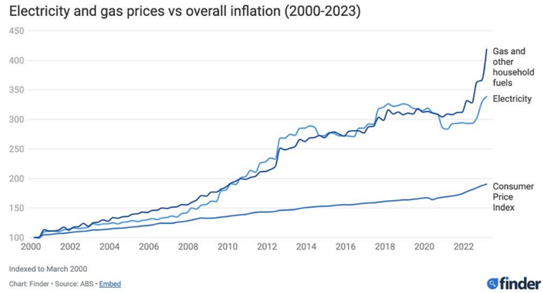

That price trajectory will continue. Though renewables are said to be cheaper than coal (and gas and nuclear) this is only the case if costs of firming of the intermittent renewables are excluded and if we exclude the costs (now set to rise considerably) of providing the increased transmission.

Firming costs are incurred because the proposed facility’s unreliable high-cost renewable energy must be balanced. We cannot rely on electricity to be supplied only during daylight hours and subject to the vagaries of weather.

The project itself incorporates a proposal for 50 MWh of battery. In fact, the storage required for system reliability with solar is far more than this.

1. Because a solar facility can only operate for one third of the day, even if operating at 100 per cent during daylight hours, the 215 MW facility is actually only 72 MW, producing (72*8) 576 MWh per day.
2. To back this up, even for a perfect day, batteries of 144 MW providing 1,152 MWh storage are required. The 50 MWh proposed is less than a twentieth of this.
3. If we also factor-in provision for five cloudy days (120 hours of storage) the *de facto* capacity of 72 MW requires additional storage of 8,640 MWh

These are very conservative numbers that do not take into account losses in storage and in charging/discharging but even then, the facility with a stated capacity of 215 MW (but actual capacity of less that 70 MW) needs 9,812 MWh of storage. At an optimistic battery cost of $300,000 per MWh (according to the US National Renewable Energy Laboratory). That means a $3,000 million additional cost for batteries, which would need to be replaced every 10 years.

The project sponsors would not incur these costs themselves, but the replacement of existing coal capacity, on which the project is founded, requires such an additional cost to allow present levels of reliability. To achieve this, the community will incur costs sixfold the stated cost of the project itself.

On top of this, increased transmission is necessary because renewable energy involves a less dense and more diffuse supply. In this respect, the plan’s costs of additional transmission expenditures compound the high cost of solar energy as generated. That transmission is only necessary because of the nature of the generation to be supplied. It is unnecessary for the consumer, who pays for it, and constitutes a further subsidy to the solar electricity provider.

The proposal is clearly against the public interest and on grounds of energy security alone, the Commission should reject it.