IPC Martins Creek Quarry Expansions – Application SSD 6612

___________________________________________________________________

I oppose the Martins Creek Quarry Expansion.

It is my assertion that the current submission SSD6612 in 2021 does not rectify nor fully address the issues of the previous submission in 2016. I also assert that the Department of Planning has not shown diligence in reviewing the submissions from residents. There is a glaring absence of recognition of the lived experience and the social amenity of all communities impacted by this application.
I lived in Paterson for over 33 years and have recently moved from the area. I do reflect on the possible destruction of the amenity and semi-rural lifestyle of the community.

Two representatives from the DPIE , Ms Jessie Evans and Mr Clay Pershaw, spoke at the public hearing and neither acknowledged the key issues of the SSD6612 submission. I reflect on some of these issues below.

HISTORY

The SSD 6612 goes against the rulings of the Land and Environment Court in proceedings:
NSWLEC 164[2016]
NSWLEC 153 [2018]
and the NSW Court of Appeal, Supreme Court:
NSWCA 147[2019].

These judgements ruled that the quarry was an unlawful enterprise and had been operating as such since 1991. It determined that the SSD should use the court findings as the baseline for the operation. Daracon (through their agent Umwelt) have ignored the court orders and selected their own baseline and throughout this whole submission not followed the determinations by various judges in both the Land and Environment Court and Supreme Court.

The premise of this submission is that it is an expansion. If the quarry has been illegal since 1991 then the concept of an expansion is questionable. Even if it accepted that an expansion of the 1991 legal quarry is valid then the baseline should be output of the quarry at that time as determined by the courts.

This is very significant in two areas; firstly, the legality of the decision based on a flawed submission and consequently the second issue is the data provided has no validity due to the incorrect baseline. As indicated by Reed (2016), Daracon were required to provide figures for an expansion of 900 000 tonnes and 1.2M tonnes as part of their submission. Most if not all consultant reports do not comply to the DPIE’s direction.

The importance of andesite to the community and state of NSW is heavily overstated.

Within the Hunter there are several quarries that have similar if not the same quality of rock.
Daracon are establishing the case that Martins Creek Quarry and its product is somehow unique. This is not the case and is quite clearly overstating the importance of Andesite and consequently negates the need of the expansion and increased truck volumes.

Both Lynwood and Peppertree (Southern Highlands) are committed to using rail as their preferred method of transport and have been since their inception.

ONGOING MONITORING
The current proposal by Daracon to expand the quarry operation after Land and Environment Court decisions, as outlined in history, is totally unacceptable and ruled against them.

There is no guarantee in this SSD that Daracon will be held accountable for the number of truck movements each day. The notion of self-regulation for Daracon is misguided. The court cases show their contempt for the community. Ms Evans form DPIE conveniently dismisses the court’s judgements as irrelevant. They cannot be trusted.

HISTORICAL HERITAGE ASSESSMENT IMPACT
The Historical Heritage Impact Assessment report is inadequate and superficial.

It seems to be a cut and paste from various reports without engaging with the readily available heritage and history of the village and district.

There are errors and omissions in the report such as Hua TSA a historic house in Clarence Town which is 30kms to the east being listed.

The report is padded out with unnecessary information to give the impression of thoroughness. This is demonstrated by the listing of buildings in Maitland well away from the haulage route. The DPIE has failed to recognise this shortcoming of the submission. It was brought to the attention of the DPIE through many submissions yet they still managed to not act on the most current and available information available to them.

My previous residence, Sunnyside, which is the oldest recorded dwelling in Paterson, is less than 20 metres from the haulage route is omitted. The following attachment can be found on CYA on the ROAD App – Paterson Historic Walking Tour. My house is the most vulnerable and Daracon/Umwelt have omitted to recognise this in their SSD.

SOCIAL AMENITY
The social amenity and lived experience of residents, including myself and the impact this expansion will have on our way of life, has the potential of destroying this historic village. The village of Paterson, Tocal Homestead and Tocal College Campus are impacted greatly by truck movements from Martins Creek Quarry. All have businesses which are valued for the ambience of the environment. This has not been addressed in their SSD6612

The volume of trucks puts enormous pressure on our community through invasion and destruction and Daracon’s proposal does not create a place of wellbeing and connection with place.

Umwelt have conducted interviews with residents directly impacted however these have been a tick and flick in my view. This was purely a process to satisfy government department and not related to real community concerns. Daracon only selecting data that suits.

My house, Sunnyside, sits in an elevated position on what is known as the dog leg in Paterson. This has been ignored in the SSD 6612 as both a real and potential problem as it is a blind corner. Umwelt are fully aware however, when raised at community meetings, still choose to ignore.
(I have attached a photo at the end of this submission showing the corner) Refer photographs numbers 3 and 4.

Daracon has not addressed the issues raised regarding the volume of trucks passing through Paterson’s main business and commercial area and they are abdicating their responsibility by avoiding the issue. The draft plan by Daracon of new road near Paterson shops and Post Office is not viable. They want to reclaim the road and allow no parking for residents to conduct their day-to-day business. Attempting to make a right-hand turn at this intersection when visiting the Pharmacist and Medical Centre is lethal when trucks are running as they cut the corner when travelling southbound. This is a huge safety issue. Adding to the safety issue is that Daracon have not had approval for this nor do they intend to complete (or even start) these roadworks before expansion activities (ie truck movements).

(Refer to photograph number 2)

NOISE, VIBRATION AND DUST
The noise, dust, pollution, and intimidation caused through sharing the road network with high volumes of heavy haulage vehicles will diminish the quality of life. Crossing the road and accessing local services can be daunting.

Recently a dust sample I had kept was sent for analysis with Greencap Laboratories SA, and it appears that on the one textile wipe there is 5% to 20% of silica dust content. This is a health risk and Daracon have not fully addressed this issue in their SSD.

The DPIE have not put any control measures in place nor have they addressed this issue.

Result from laboratory testing was as follows:
The dust consists of off-white and black silt sized particles and fine sand-sized particles. The black particles were removed during the ashing process, indicating they may be carbon base e.g., soot, coal dust, creosote etc. it is suspected that fly ash is present which is toxic.

There is not a single word in the SSD 6612 regarding fly ash.
Information provided then outlines the content of silica as mentioned above. SSD does not mention Andesite as having high silica content.
Nor has the DPIE reviewed or investigated any of these issues. It has not made any reference to them in any of their documentation. This is a failing of the process.

The proposed SSD 6612 would see additional truck traffic (280 truck movements per day) which would significantly impact regional air quality along the proposed haul route.

The daily emissions of diesel exhaust from hundreds of gravel trucks generate nitrogen oxide, sulphur dioxide, carbon monoxide and volatile organic compounds (VOCs)

MENTAL HEALTH
During previous years with an illegal Quarry operation and hundreds of trucks per day rattling through our village, I suffered anxiety, stress and depression

Karen Lamb, Social Scientist with Umwelt, did not accept our lived experience at Community Meeting held on the 11^{th of} February, 2021 at Tocal. Ms Lamb has failed to acknowledge our real life or lived experience.

As a community we cannot continue to live as if on a mining site. Communities should not continue to endure the suffering imposed by Daracon. They have complete disregard for all of us and this has been shown by their attitude in all community consultations.

Daracon’s glossy application is so technical they have neglected to focus on what our community asset is and that is our rural lifestyle and heritage. The DPIE need to acknowledge our lived experience.

CONCERNS
The DPIE has approved such monumental changes without consideration of how this expansion would impact the community and the environment which includes, polluted air and destruction of native vegetation and habitat.

A recent public meeting held at Tocal Ag College in June, confirms that surrounding communities in the Maitland City Council Shire have not been approached by Daracon or Umwelt and will be further impacted. A recent approval of the Hanson Quarry at Brandy Hill will impact those residents along the haul route from Bolwarra to East Maitland. There are surely some issues with governance that allows an organisation such as Daracon to assume and apply such power with limited diligence.

Daracon’s monitoring of the contractors is inadequate and without any community safety measures. Future changes to the operation are also of great concern. The DPIE does not value our heritage in NSW. Paterson provided most of the red cedar to build the mansions and public buildings found in Sydney today and is historically significant.

I sincerely hope you find the time to respond, and help impacted communities reclaim their standard of living.

SUMMATION
The recent approval of the expansion of the Brandy Hill quarry was conditional on the applicant completing infrastructure improvements BEFORE operations were commenced.

The DPIE has agreed to Daracon making a vague and open-ended statement that it MIGHT improve some serious infrastructure improvements. Read the attached court rulings and it will be noted that Daracon have a poor track record of compliance.

The Department of Planning needs to be acutely aware of how the Martins Creek Quarry (MCQ) is impacting the social amenity of our communities. We cannot continue to live our lives as if on a mining site which impacts the social amenity of our communities. Communities do not have to endure the suffering that this community has endured. The current situation is totally unacceptable.

Governments are spending millions to bypass country towns, create expressways and tunnels in cities. It seems illogical to contemplate putting all these trucks onto the road through Paterson when the quarry is on a railway line.

Data provided by the Department of Planning in a letter dated the 6th of December 2016 in response to the first SSD 6612 by author Howard Reed, the then director, outlines key areas that were not addressed or given insufficient attention. This also applies to current proposal from Daracon and Umwelt. Highly flawed.

I strongly object to the expansion of the quarry, but if expansion is to occur then the material must be moved by rail.

Thank you for your time.

PHOTOGRAPHS
PHOTO 1
Early morning run through Paterson on a quiet morning

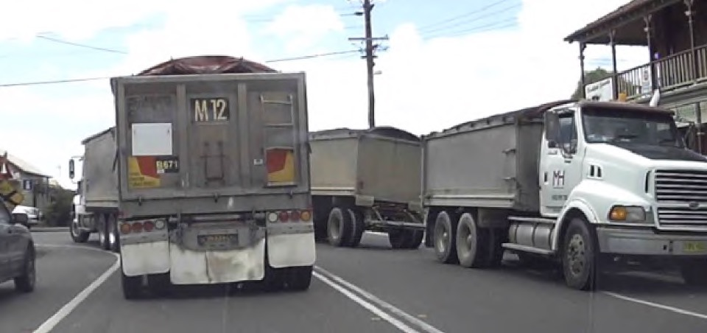
PHOTO 2
PO Corner on left and King St on right. School Bus stop also on left hand side in front of CBC Bank Building corner. To visit the Pharmacist and Medical Centre making a right-hand turn into King St is treacherous.

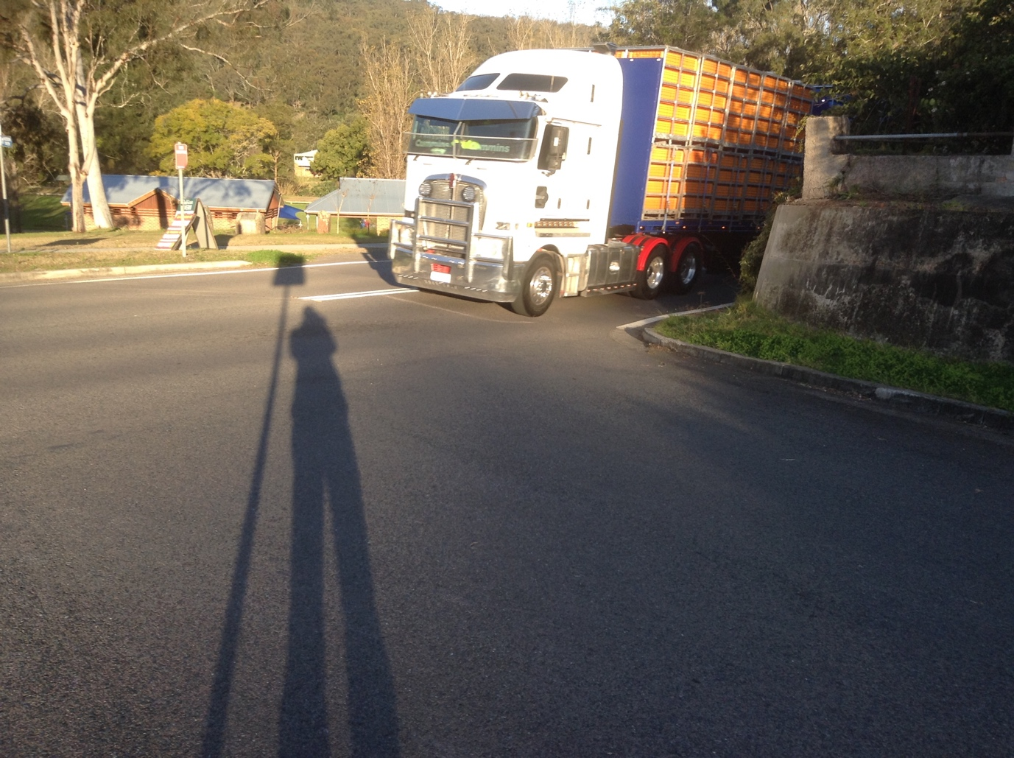

PHOT0 3
Dog Leg which has been totally ignored by Daracon. My house Sunnyside sits on this corner

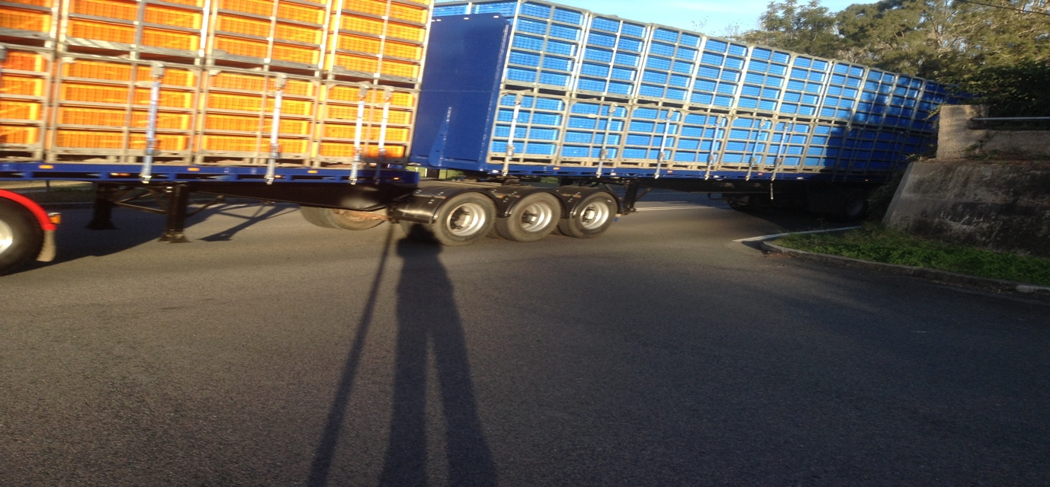

PHOTO 4
This corner is very dangerous, and Umwelt have conducted interviews with my husband and I outside when trucks were running. Daracon have omitted to mention in their SSD.

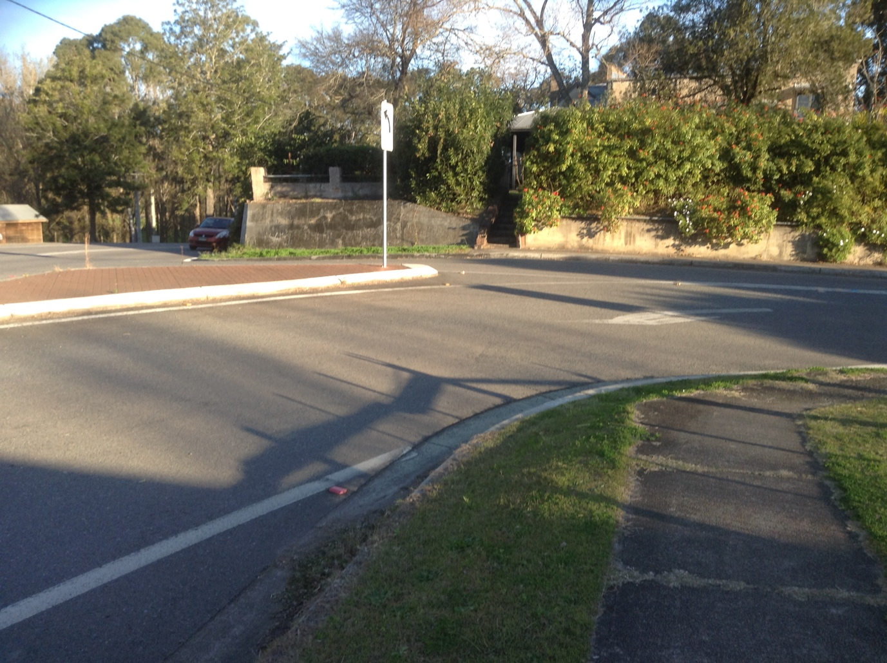
PHOTO 5
This dangerous intersection was identified and referred to Umwelt then the DPEI. No one has recognised the importance of this intersection.

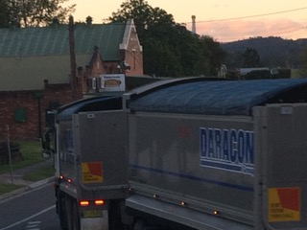

PHOTO 5
View from front garden of Sunnyside.

